**TABLEAU ASSIGNMENT 01**

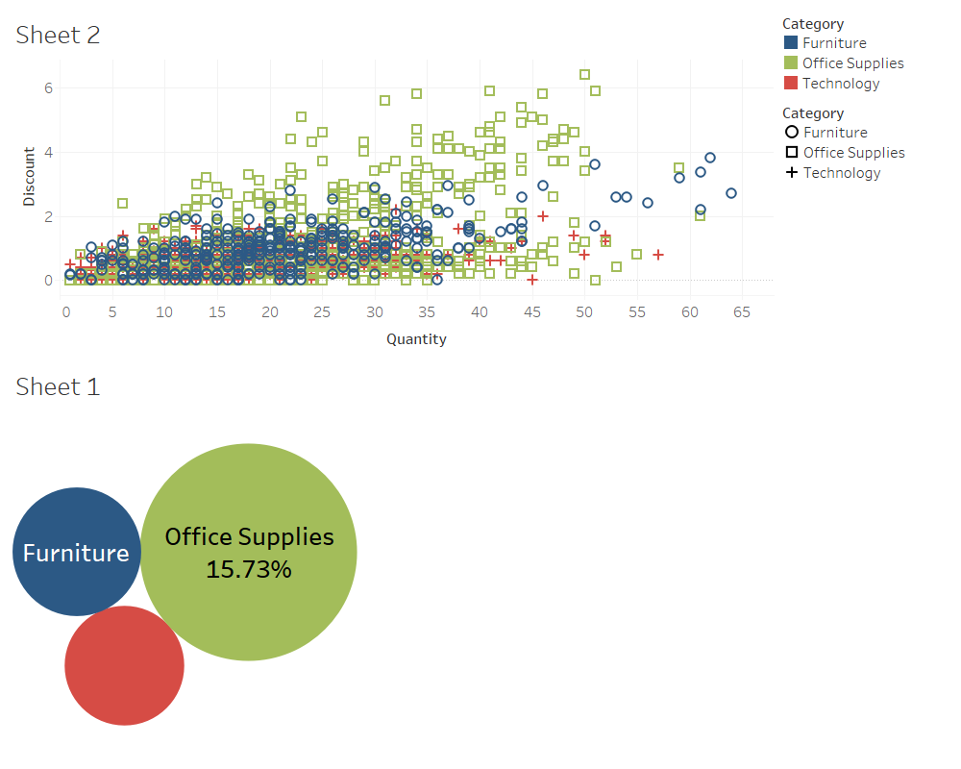**03. Using the “Sample-Superstore.xls” file, create a scatter and a bubble plot between different measures in the dataset and observe the type of correlation (negative or positive or no correlation) between them. Draw a comparison between the bubble chart and the scatter plot.**

**04. Consider that you are an HR representative for a multinational company. The staff database is under your control. There are certain details regarding employees that you must never divulge. However, there are many bits of information about employee abilities and skills that may be shared. Using the data extract option in tableau, build a packaged worksheet and use the option "Hide All Unused Fields" in the data extract feature to hide all the fields- dimensions and measures which you haven’t used in the visualization and do not wish to share with employees. Feel free to use any HR dataset or you may even create a dummy data for illustration purpose**

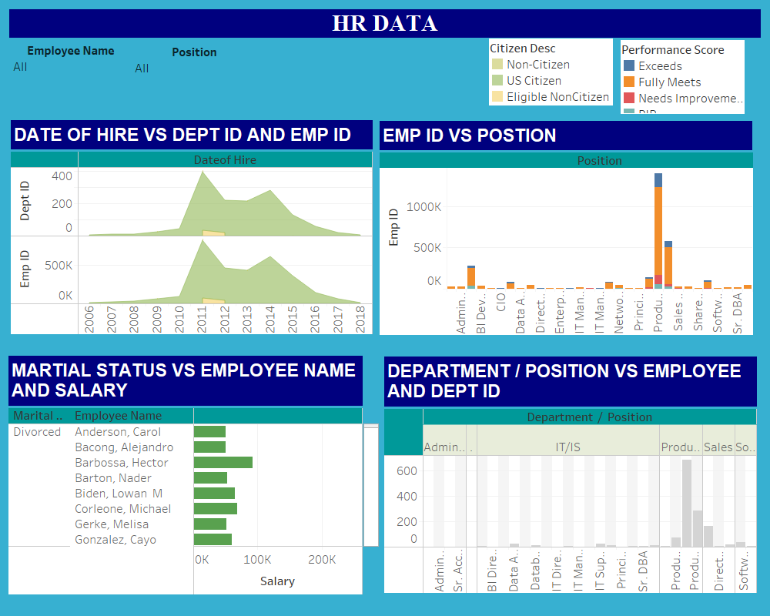

**1.“twbx” is a bundled workbook for Tableau. The original .twb file is bundled with the data source in this package. It can be compared to a compressed file. It contains all the information and instructions required to operate in Tableau. Since the data is contained within the .twbx file itself, one can still access and use it without a network or Internet connection. The .twb file and the data source can be separated from the .twbx file by unpacking it. Pick up any dataset of your choice, create a simple bar chart using the fields of the dataset and save the visualization created in. twbx format. Analyze the properties of the newly created twbx file and segregate the .twbx file into .twb and data source.**

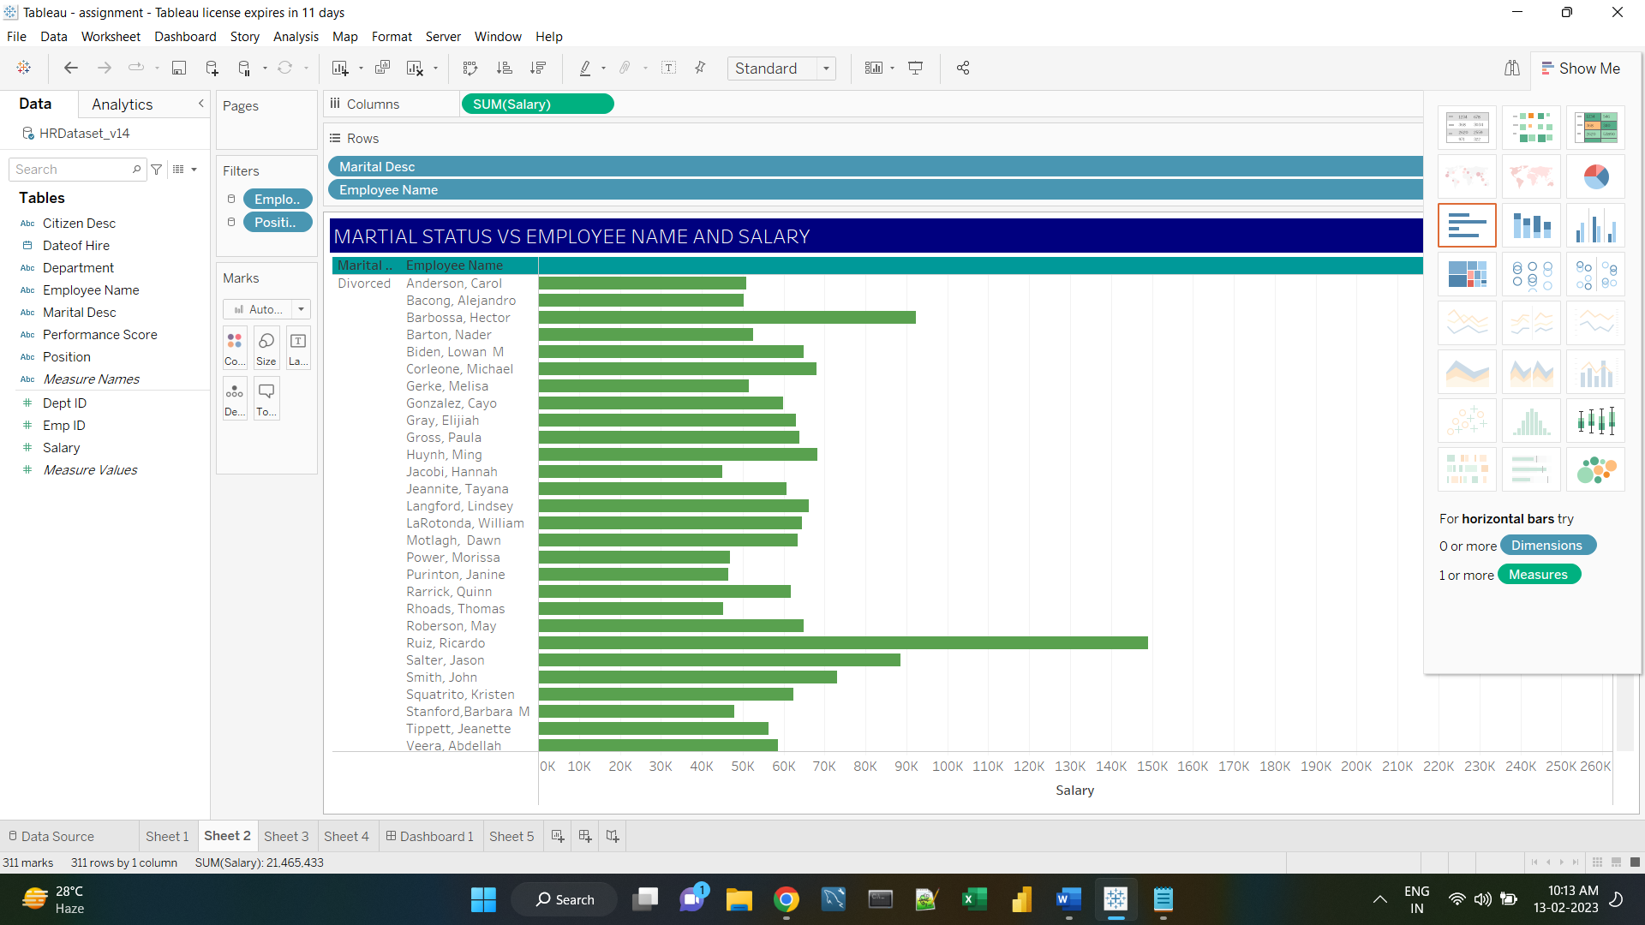

**2. Briefly explain the utility of the Tableau bookmark feature and create a simple bookmark file. Observe the format of the bookmark file and mention the location in which it is saved.**

Bookmarks can be accessed from any workbook using the Bookmarks menu. When you open a bookmarked worksheet, it adds the worksheet to your workbook in the state that it was in when it was bookmarked. It will never update or change automatically. Bookmarks are convenient when you have worksheets that you use frequently.

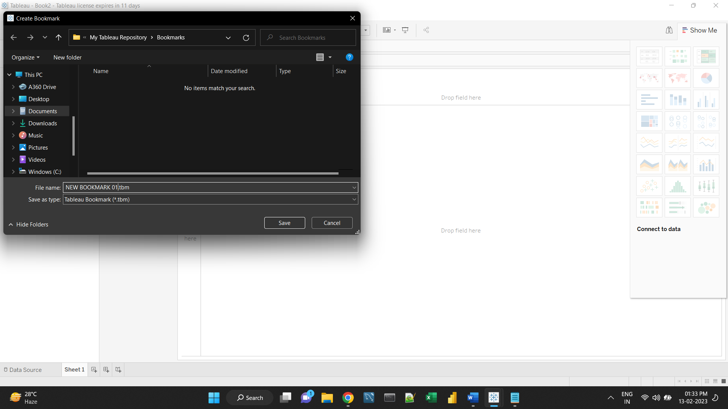

* Using tableau bookmarks, files can be shared with other users.
* Usually, a bookmark contains a single worksheet that can be used by others on multiple workbooks.
* Tableau bookmark files have a. tbm extension.
* Steps to create a Bookmark:

Window -> Bookmark -> Create Bookmark -> Name of Folder -> Save.

It is saved in My Tableau Repository in the document folder named as Bookmarks.

**5. Discuss the differences between the “Measure Names” and “Measure Values” pre-defined features in Tableau. Using the “PowerStore_USA” dataset available in your iNeuron resources, create a visualization using “Measure Names” and “Measure Values” and mention the fields that fall into each category- “Measure Names” and “Measure Values”.**

The Data pane always contains a number of fields that do not come from your original data, two of which are **Measure Values** and **Measure Names.** Tableau automatically creates these fields so that you can build certain types of views that involve multiple measures.

The **Measure Values** field contains all the measures in your data, collected into a single field with continuous values. Drag individual measure fields out of the Measure Values card to remove them from the view.

The **Measure Names** field contains the names of all measures in your data, collected into a single field with discrete values.

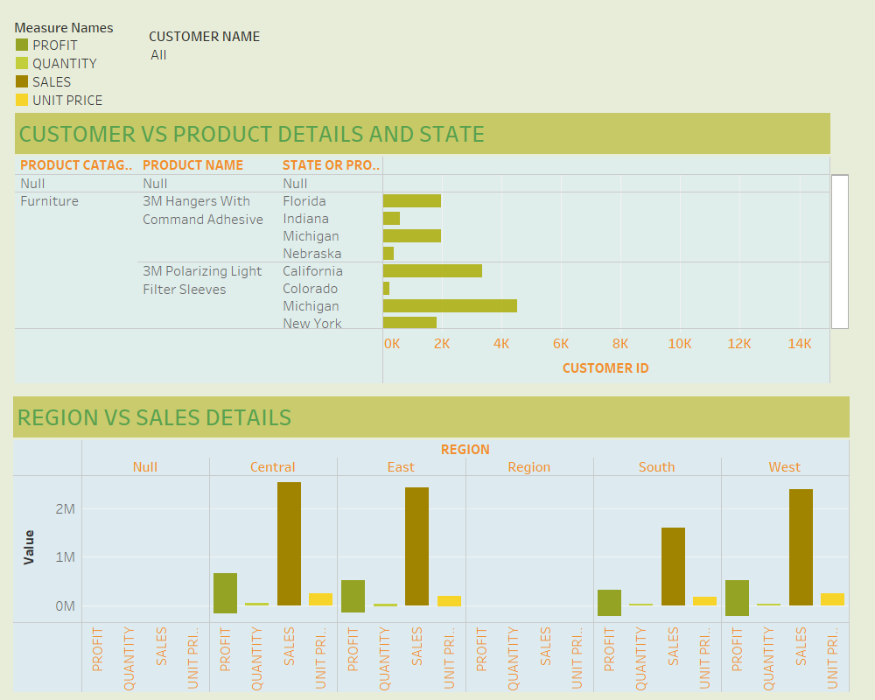

**MEASURE NAMES**

**F13- PRODUCT NAME**

**F15- REGION**

**F10- PRODUCT CATAGORY**

**F11- PRODUCT SUB-CATAGORY**

**F12- PRODUCT CONTAINER**

**F7- CUSTOMER NAME**

**F8- SHIP MODE**

**F9- CUSTOMER SEGMENT**

**F16- STATE OR PROVINCE**

**F17- CITY**

**F19- ORDER DATE**

**MEASURE VALUES**

**#F14- PRODUCT BASE MARGIN**

**#F21- PROFIT**

**#F22- QUANTITY**

**#F23- SALES**

**#F3- DISCOUNT**

**#F4- UNIT PRIZE**

**#F5- SHIPPING COST**

**#F6- CUSTOMER ID**

**#F24- ORDER ID**

**#F18- POSTAL CODE**